Agile Development: An Overview

Introduction
- Let’s go back in time to early software companies. Back in the day, large programs, though consisting of many different components (ex. front-end, back-end, hardware communication, etc.), were always dealt with as a whole rather than in parts. This was known as a monolithic application. Everything was combined into a single program on a single platform.
- For smaller programs in which tight-knit development teams knew the software inside-out, this worked and was quite streamlined and effective. However, as software programs continued grow, and with them the development teams, this quickly became unfeasible.
  - As programs grow, it becomes more difficult and unrealistic that each developer knows each part of the program well. Moreover, when every developer tries to work on the whole program rather than focus on one or two, it greatly reduces the capability for specialization and, thus, innovation.
  - Another issue arises when bugs exist in the program. When one mistake messes up the entire program, it becomes next to impossible for a developer to test, understand, and debug their work. The testing phase, then, is delayed until the final half of the project.
  - Finally, a third issue arises from the time and potential merge conflicts that arise when the developer has to actually push the application. The compilation of a multi-gigabyte build can take hours, making it impossible for devs to complete work in working hours. As well, working with other devs also becomes difficult, especially considering that coding is largely self-driven.

What is Agile?
- Before, companies used a “Waterfall Model” Approach
  - Requirement Gathering
  - Software Design
  - Implementation
  - Verification
  - Maintenance
- But this doesn’t work in today’s software industries because there are multiple changes being pushed on a daily basis.
- Enter Agile
  - Agile is a methodology to rapidly deploy software in a very organized manner
    - Rapid deployment of code without significant time constraints and delays
    - Small chunks of code can be shipped to the client, or merged into a larger build, without affecting other areas
  - Agile is a chain of rapid development and deployment
    - You have a big idea of what you want to build, but you break it down into smaller, more manageable chunks, and work on one chunk at a time.
    - In practice, different developers will work on different chunks every day, and their chunks are separated such that the code does not overlap. As a result, they can develop and build without interference
  - In most Agile environments, you work in iterations. You have a set of tasks ordered by priority which you know need to be completed, and go through them one at a time.

Steps of Agile
- Plan
- Design
- Develop
- Test
- Deploy
- Review
- Launch

Key Values of Agile
- People Over Processes and Tools
  - Development- and client-centric
  - Just because certain processes and tools have previously been followed doesn’t mean that we can’t adjust or go in a different direction
  - People are given more importance
- Working Software Over Comprehensive Documentation
  - Before, every application had hundreds of pages of documentation on classes, methods, design, etc.
  - But, all I care about is how it works and what I have to do to improve it
    - For good coders, code + comments is enough for documentation
- Customer Collaboration Over Rigid Contracts
  - Very feedback-dependent
  - There may be a plan and an agreement, but what is more important is overall collaboration and satisfaction
- Responding to Change Over Following a Plan (Adaptability > Rigidity)

Principles of Agile
- Satisfy the customer
- Welcome changing requirements
- Deliver working software frequently
- Frequent interaction with stakeholders
- Motivated individuals
- Face-to-face communication
- Measure by working software
- Maintain constant pace
- Sustain technical excellence and good design
- Keep it simple
- Empower self-organizing teams
- Reflect and adjust continuously

Advantages of Agile
- Persistent software delivery
- Increased stakeholder satisfaction
- Inspect and adapt
- Welcome to changes at any stage
- Design is important
- Daily interaction

Frameworks of Agile for Real-world Implementation
- Ex.
  - Scrum
  - Lean
  - Scrumban
  - Kanban
  - Crystal
  - eXtreme Programming

Scrum
- Scrum is by far the most widely-used framework, and is often combined with other frameworks for a hybrid working model
- In Scrum, we iterate over changes one at a time
- In Scrum, we:
  - Plan
  - Build
  - Test
  - Review
- A Scrum-implemented team has the following team members:
  - Product Owner
    - Like a manager
    - Holds responsibility to ensure the application is deployed and built according to the specifications
    - Doesn’t necessarily have to be technically-proficient
    - Holds all accountability from higher-ups
  - Scrum Master
    - Like a team leader
    - Right below the product owner in the hierarchy
    - Handles day-to-day operations like running meetings, planning tasks, etc.
  - Team, consisting of:
    - Developers
    - Testers
    - + other potential roles
- Steps of Scrum Development
  - Product Backlogs
    - Iterations of the application are iterated over in smaller tasks, and over time, you develop a collection of tasks that should be done for the product
    - Backlogs are developed by Product Owner or Scrum Master
    - It’s basically a master list of everything we want to have done for the product
  - Users Stories
    - Each part to be implemented from the product backlog becomes a story
    - The stories are given certain priority levels by the scrum master or product owner
  - Sprint Backlog
    - Gives an organized and prioritized plan of stories to work on and aim to complete during set periods of time
    - Given logical and reasonable list of tasks to complete one-at-a-time
  - Sprint Planning
    - A meeting during which the product owner or scrum master will explain the end goal of the product at the end of the sprint
  - Daily Scrums
    - Daily or other scheduled, routine meetings during which plans, progress, and setbacks are discussed
  - Sprint Review
    - At the end of the sprint, we look back on our work
      - What were we able to complete?
      - Positives? Negatives? Learnings?
    - Demo what we worked on, prove that it’s completed

- 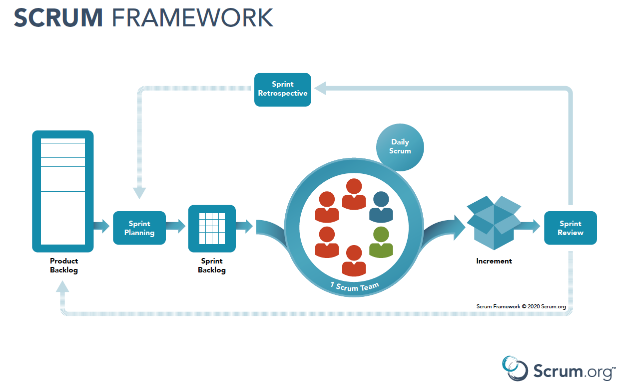

Other Frameworks
- Extreme Programming (XP)
  - Precursor to Scrum
  - 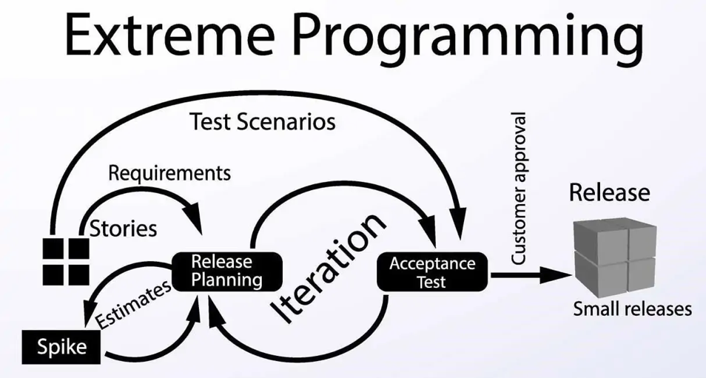
- Lean Programming
  - Principles
    - Eliminate Waste
    - See the Whole
    - Build Integrity
    - Empower the Team
    - Decide as fast as possible
    - Decide as late as possible
    - Amplify learning
  - Want to have a cross-functional team
    - Devs can cross over and work on different features with high proficiency
    - Team’s responsibility to delegate and work on task based on timeline
- Kanban
  - No such thing as a “sprint”
  - Rather, we have a list of tasks in the queue that need to be done that exist in categories representing their state. These states can be, for example:
    - Analysis
    - Design
    - Development
    - Testing
    - Integration
    - Verification
    - Etc.
  - Once we finish a goal for a task, we move it into the next state
- Crystal

Source:
https://www.youtube.com/watch?v=WjwEh15M5Rw
(Edureka, 08/02/2019, What is Agile? | Agile Methodology | Agile Frameworks - Scrum, Kanban, Lean, XP, Crystal | Edureka)

